No Room in the Inn
by
Sue Faris Raatjes©
It was Christmas morning, 2014, in San Diego. The day was cold and crisp. My husband and I opened the doors to our car parked in the garage of the Holiday Inn. We were eager to drive the ten minutes to our son's home. His young daughters were holding off the Christmas celebration until Grandma Sue and Grandpa Bob arrived. No time to waste!
That's when it hit us: a waft of strong, putrid smoke. Someone had been smoking in our car! How did they get in? Did we forget to lock the doors?
Immediately, I thought of the gifts--some of them cash--in the trunk. More importantly, I feared for the Dutch pastry carefully balanced on top of them. That pastry took me two days to make and it better not be eaten! I thought.
We popped the trunk. Nothing was disturbed. We checked the backseat of the car and everything there looked fine, also. "What is going on?" we asked each other.
Obviously, we had an overnight visitor in our car. It was a tidy and considerate visitor who left nothing behind. After we assured each other the car had been locked, we both became silent. Christmas morning. The night had been very cold. It was only right someone should spend Christmas Eve in the cozy back seat of our Ford Taurus, rather than under a bridge or on the cold California beach--even someone who knew how to jimmy a lock.
Christmas Eve. No room in the inn. Jesus born in a manger, "...because there was no room..." Who can be upset?
That smoky smell lingered for a long time. It served as a reminder of the tragedy of people needing warmth and shelter, especially on Christmas. I am touched and saddened. Who else needs to find a room in the inn? Who else needs to find the love of the Savior?

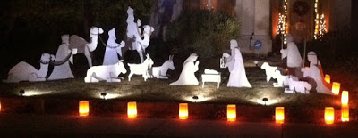
Photo courtesy Lorraine Eyer

